**ULR Renderer v 1.0 (alpha)**

**Java Runtime**

You must have version 1.8 of the java runtime (JRE) installed to run the renderer. It can be obtained from <http://java.com>

**Quick Start Guide**

Follow these instructions to load a model that has already been processed by PhotoScan

* Export the data from PhotoScan
  + Exporting the Model:
    - Select “File🡪Export Model…” from the menus
    - You can save it anywhere you like but make sure the type is “Wavefront OBJ”
    - The default export parameters are sufficient
  + Exporting undistorted images:
    - Select “Tools🡪Export🡪Undistort Photos…”
    - The settings should look like this:  
      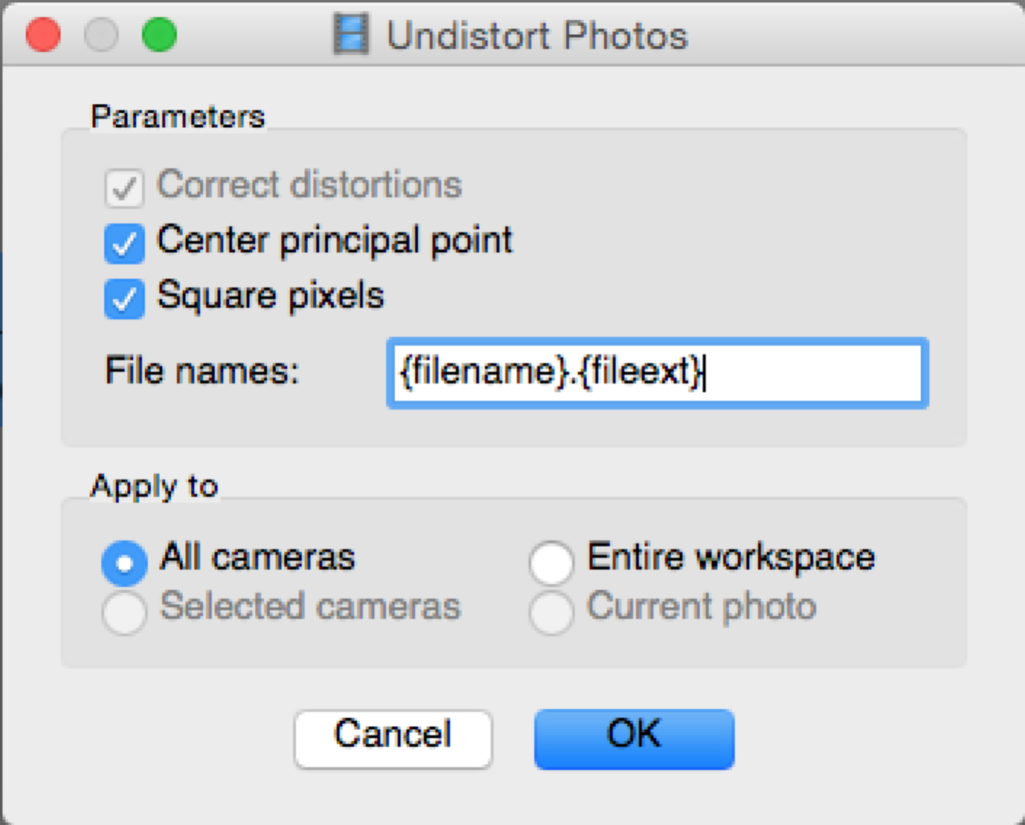
    - Click OK and point it to a directory to place the images
    - Note: you can replace {fileext} with a specific image type (such as png) and it will convert the exported files to that type however, if this is different from the type of the original images you may experience issues.
  + Exporting Camera Positions:
    - Select “Tools🡪Export🡪Cameras…”
    - Make sure the type is set to PhotoScan XML
    - You can name it anything you like
* Run the ULF Renderer and click the ‘Load Single’ button
  + Point it to the XML file you exported
  + Then point it to the OBJ file and the folder with the undistorted images
  + Please wait while the images are loaded (this may take some time especially for high-resolution images)

**Loading the Zip file examples**

A few prepared examples have been included as Zip files that are a bit easier to load:

* Start the ULR Renderer and click the ‘load single’ button
* Change the type to Zip Archive
* Select the example you want to load

Note: this will only work with the prepared zip examples. We will include some instructions at a later time for creating your own zip archives.

**Controls**

You can interact with the loaded object as you would with most objects in other 3d programs. This is often referred to as a ‘trackball’ controller:

* Click and drag to rotate around the object’s center
* Use the mouse scroll wheel to zoom in and out

**Settings Window**

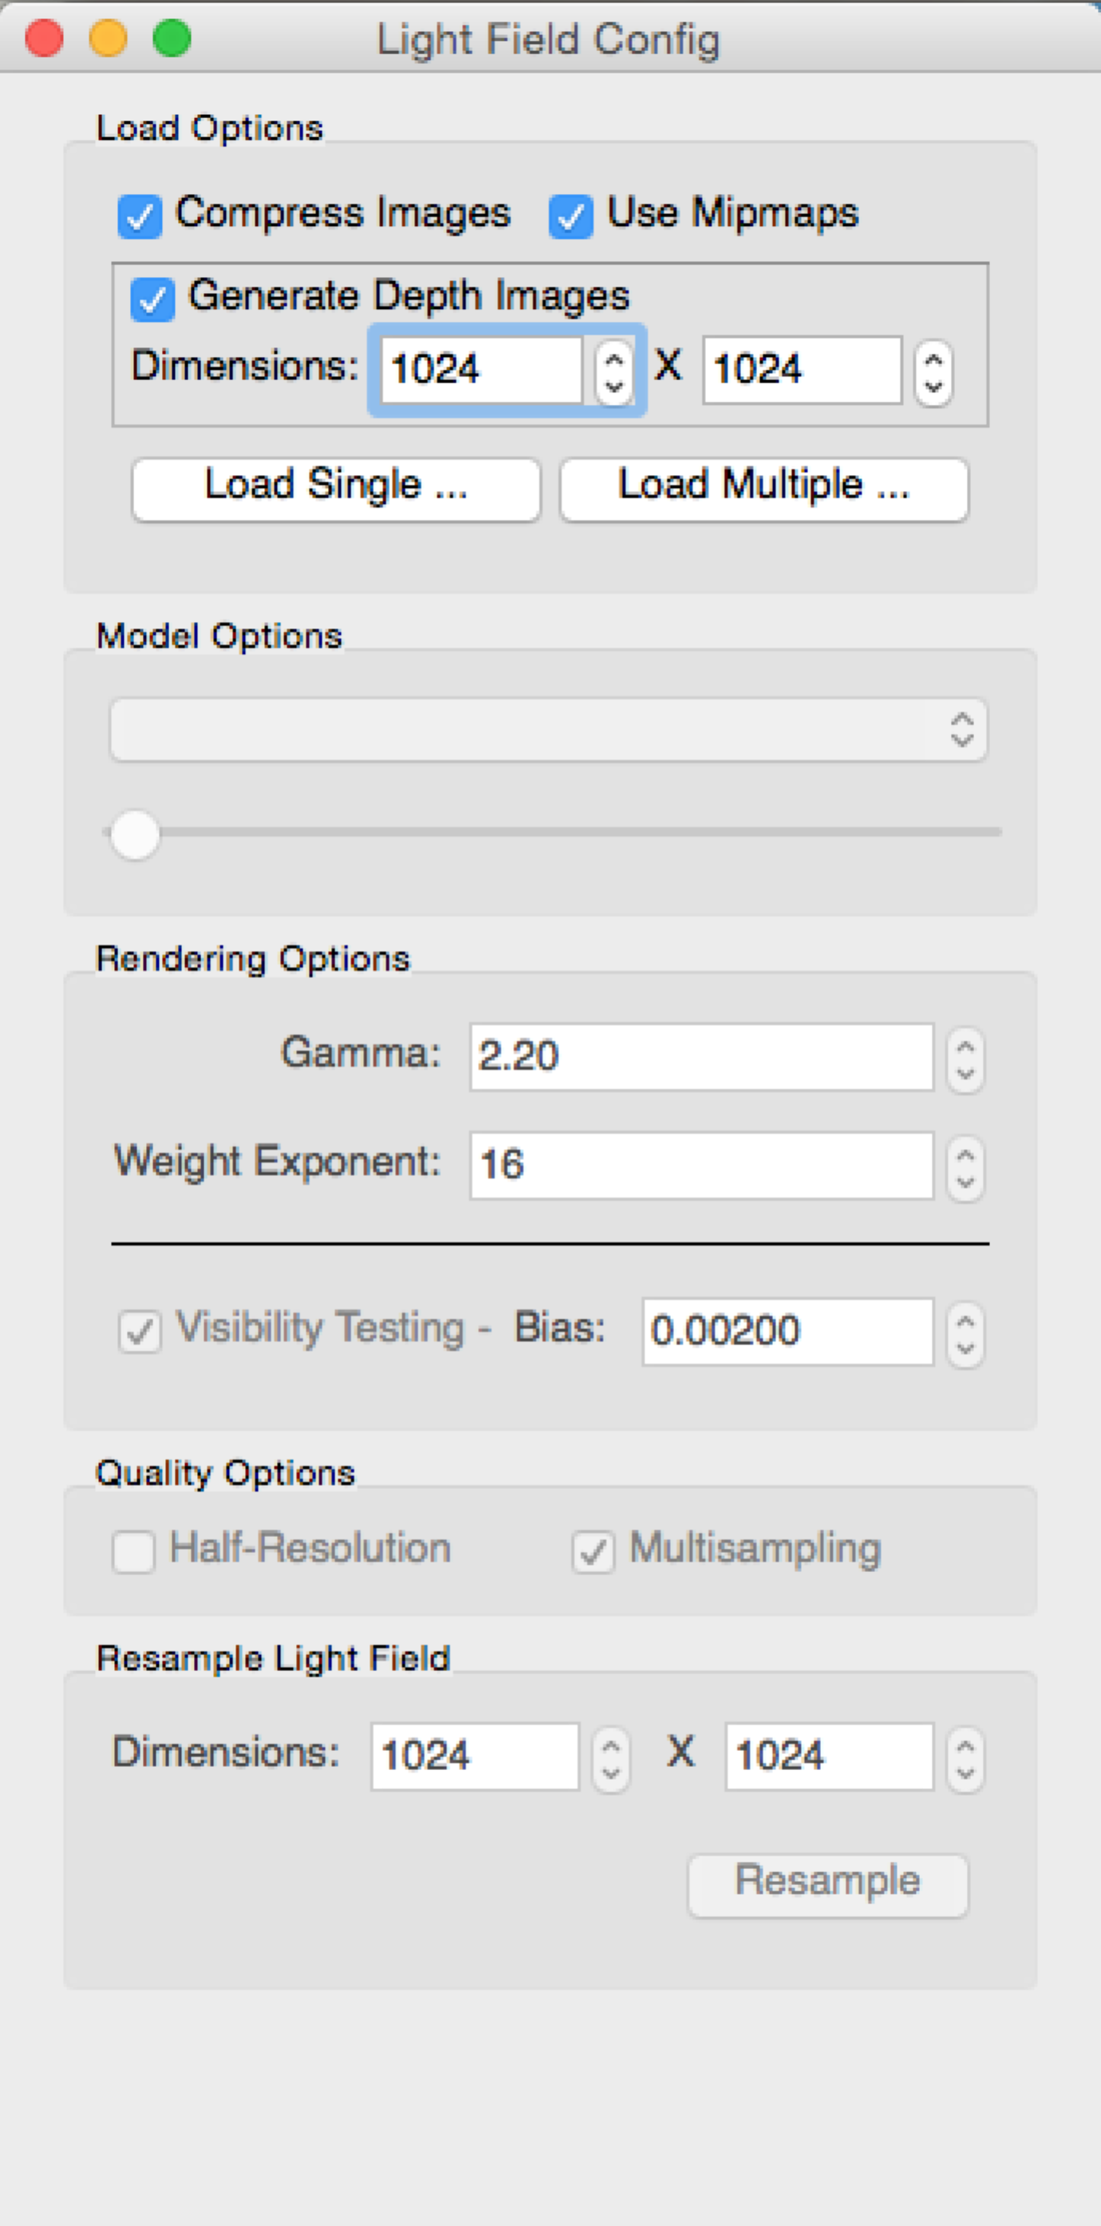The settings window at the left of the main object helps control the renderer. The default options should be a good starting point but some changes will help improve performance:

* Weight Exponent
  + Adjust lower to avoid black areas where no good views were available.
  + Adjust higher to get a sharper image.
* Half-Resolution
  + Render at half the native resolution (faster but will appear pixelated)
  + This is recommended when on a Retina display
* Compress Images, Use Mipmaps &  
  Generate Depth Images
  + Controls use of GPU memory.
  + Disabling ‘compress images’ will slightly improve rendering quality but use *more* memory.
  + Disabling use Mipmaps or Generate Depth Images will use *less* memory but may result in rendering artifacts.